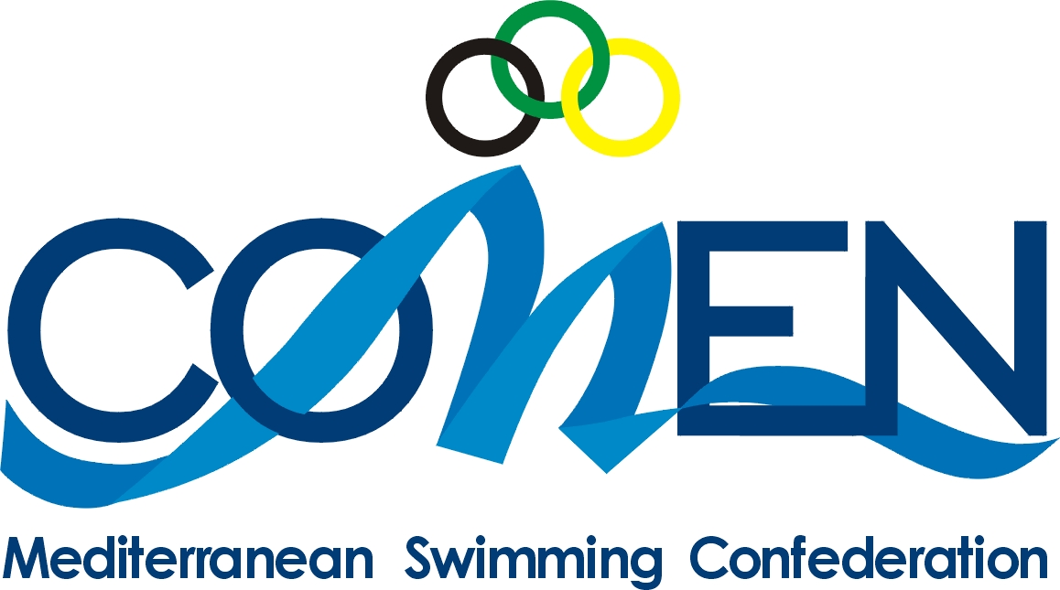
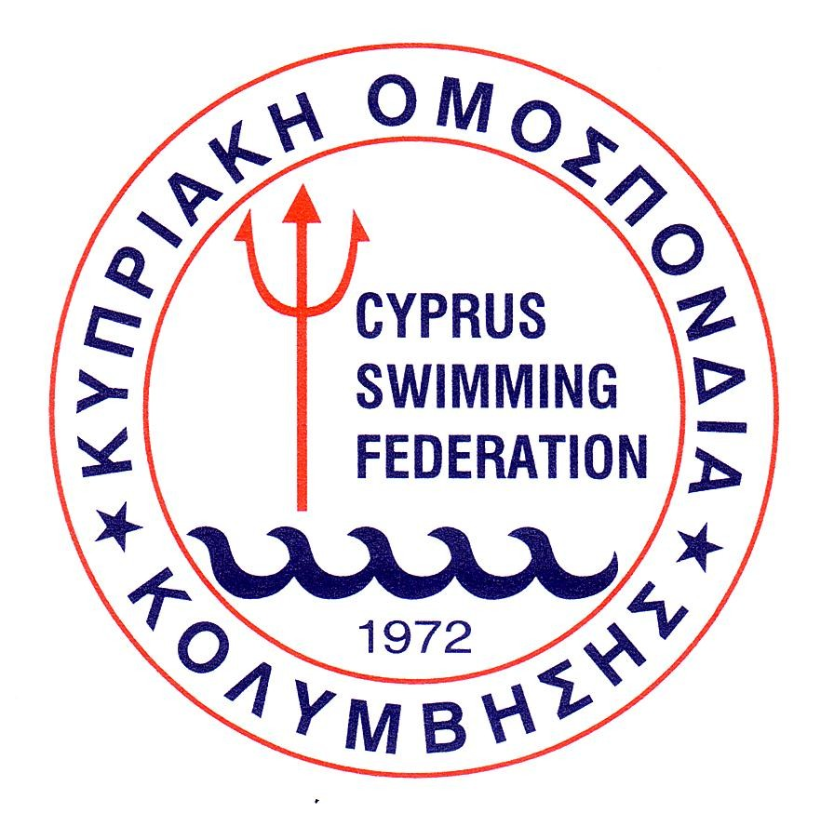
MEDITERRANEAN OPEN WATER
SWIMMING CUP 2011
&
7TH CYPRUS INTERNATIONAL MARATHON

LIMASSOL 22-23/10/2011

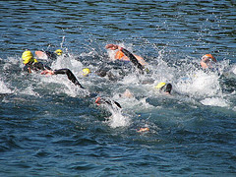

Official Sponsors:



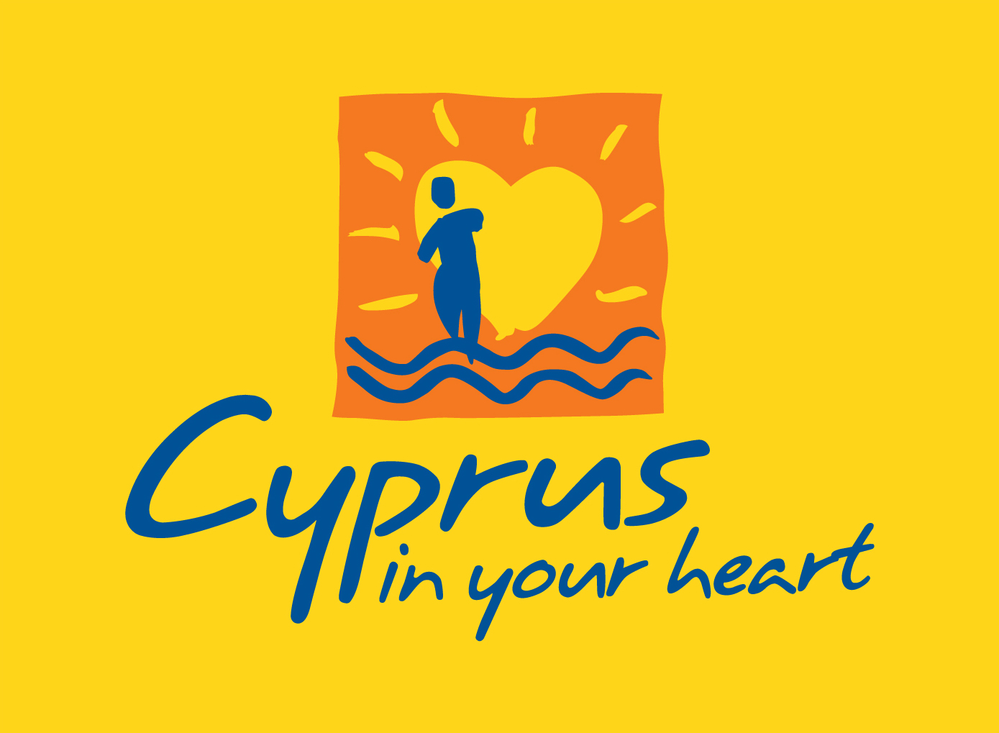

CYPRUS TOURISM CYPRUS SPORTS
ORGANIZATION ORGANIZATION

Dear Friends,

We have the pleasure to invite you to participate in the MEDITERRANEAN OPEN WATER SWIMMING CUP 2011 and the 7th CYPRUS International Swimming Marathon that will take place at Limassol, on Saturday 22nd & Sunday 23rd of October 2011.

- Organizers : Cyprus Swimming Federation
Address: P.O.Box 23931,
1687 Nicosia, Cyprus
Phone: 0035722449840
Fax: 0035722449842
E-mail: koek@logos.cy.net
Web site: www.koek.org.cy

Contact Person: Mrs Maria Kyriakou

- Location : City of Limassol (65 km from Larnaca official airport)

- Venue : Open Sea area in front of the Famagusta Nautical Club
(parallel to the Cyprus Tourism Organization beach).

- Rules applicable: The event will be conducted in arrcordance with FINA
Open water swimming rules

- Eligibility : MEDITERRANEAN OPEN WATER SWIMMING CUP
Men 16 to 17 years (born in 1995/1994)
Women 14 to 15 years (born in 1997/1996)

CYPRUS INTERNATIONAL SWIMMING MARATHON
Men and women 14 years and older (born 1997 and older)

- Distance : MEDITERRANEAN OPEN WATER SWIMMING CUP
5 km individual for men
5km individual for women
2,5kmTeam event

CYPRUS INTERNATIONAL SWIMMING MARATHON
5km individual for men
5km individual for women
10 km individual for men
10km individual for women

- Course : 1250m long clearly marked (oblong sausage shape)

Water temperature will be appoximately between 25°-26° C
The waters depth will be between 2 and 5 meters

- Start of race : One start, common for Men & Women
For the MEDITERRANEAN 2,5km Team Event, the starting order for the participating Federations will be decided by draw. There is going to be one minute difference between each starting country.

- Schedule : Friday 21/10/2011
17.00 Technical Meeting for COMEN Technical Open Water
Swimming Committee (Famagusta Nautical Club)
19.00 Technical Meeting (Famagusta Nautical Club)
for coaches, delegates and athletes

Saturday 22/10/2011
  - Swimmers accreditation and numbering for the
MEDITERRANEAN – 2,5km Team event
  - Briefing
Federations and Swimmers Presentation
for MEDITERRANEAN – 2,5km Team event
08.30 MEDITERRANEAN - 2,5kmTeam event start
09.00 Swimmers accreditation and numbering for
CYPRUS INTERNATIONAL – 10km men and women
  - Briefing
Federations and Swimmers Presentation
CYPRUS INTERNATIONAL – 10km men and women
10.00 CYPRUS INTERNATIONAL – 10km men and women
start

Sunday 23/10/2011
07.30 Swimmers accreditation and numbering for the
MEDITERRANEAN and CYPRUS INTERNATIONAL
5km men and women
09.15 Briefing
Federations and Swimmers Presentation
  - MEDITERRANEAN and CYPRUS INTERNATIONAL
5km men and women start
12.00 (Approx.) Awards ceremony for all the events

- Prizes : MEDITERRANEAN OPEN WATER SWIMMING CUP * Cup for the 1st, 2nd and 3rd Federation in 5km men
* Cup for the 1st, 2nd and 3rd Federation in 5km women
* Cup for the 1st, 2nd and 3rd Federation in 2,5km team
event
* Cup for the 1st, 2nd and 3rd overall Federation
The overall points will be calculated for each Federation
by adding the points received from the 3 best swimmers
of the 5km men and 5km women and the points received
from the 2,5km team event.

Points: 1st - 20 points
2nd - 17 points
3rd - 15 points
4th - 14 points
And so on until the 16th place which receives
2 points.
All other swimmers finishin the race before the cut-off time shall receive one (1) point

* Cup and medal for the 1st athlete in 5km men and medal
for the 2nd and 3rd athlete

* Cup and medal for the 1st athlete in 5km women and
medal for the 2nd and 3rd athlete
* Cup and medals for the 1st team in 2,5km team event
* Medals for the 2nd and 3rd athletes in 5km men, 5km
women and team event

CYPRUS INTERNATIONAL SWIMMING MARATHON
* Cup and medal for the 1st athlete in 5km men and medal
for the 2nd and 3rd athlete
* Cup and medal for the 1st athlete in 5km women and
medal for the 2nd and 3rd athlete
* Cup and medal for the 1st athlete in 10km men and medal
for the 2nd and 3rd athlete
* Cup and medal for the 1st athlete in 10km women and
medal for the 2nd and 3rd athlete

- Entry fee : €30 per swimmer payable at registration
(FREE for teams if accommodation booked
through Cyprus Swimming Federation)

- Accommodation : PARK BEACH HOTEL (***) – 5 minutes walking distance
from the venue
The prices are per person per day full board (three meals per day, no drinks included) as follows:

Single room : 75.00 Euro
Double room : 55.00 Euro
Triple room : 50.00 Euro
All reservations must be done through the Cyprus Swimming Federation.
- Transportation : Transport from Airport /Hotel/Airport, will be provided free
of charge only for the official dates, when accommodation is booked through the Cyprus Swimming Federation.
- Official Dates : Arrival – 20 or 21 of October 2011
Departure – 23 or 24 of October 2011

DATES TO REMEMBER
- Preliminary Entry and Accommodation Form : 30/09/2011
- Final Accommodation and Travel Form : 10/10/2011 with the total amount payment
- Final Entry Forms : 10/10/2011
- Delegation Form : 10/10/2011
We look forward to welcome you, and in the meantime I convey to you my
personal wishes,
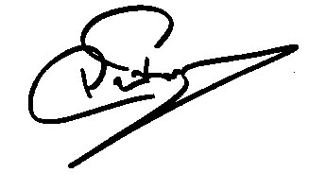
Panikos Prokopiou - President

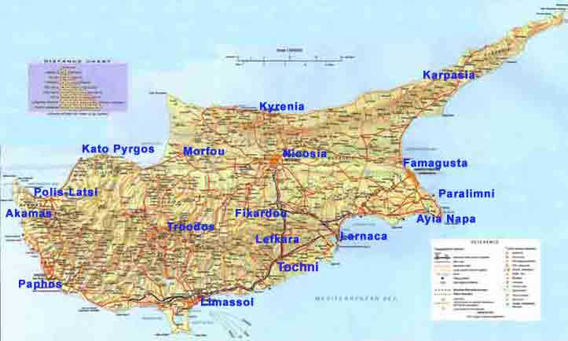

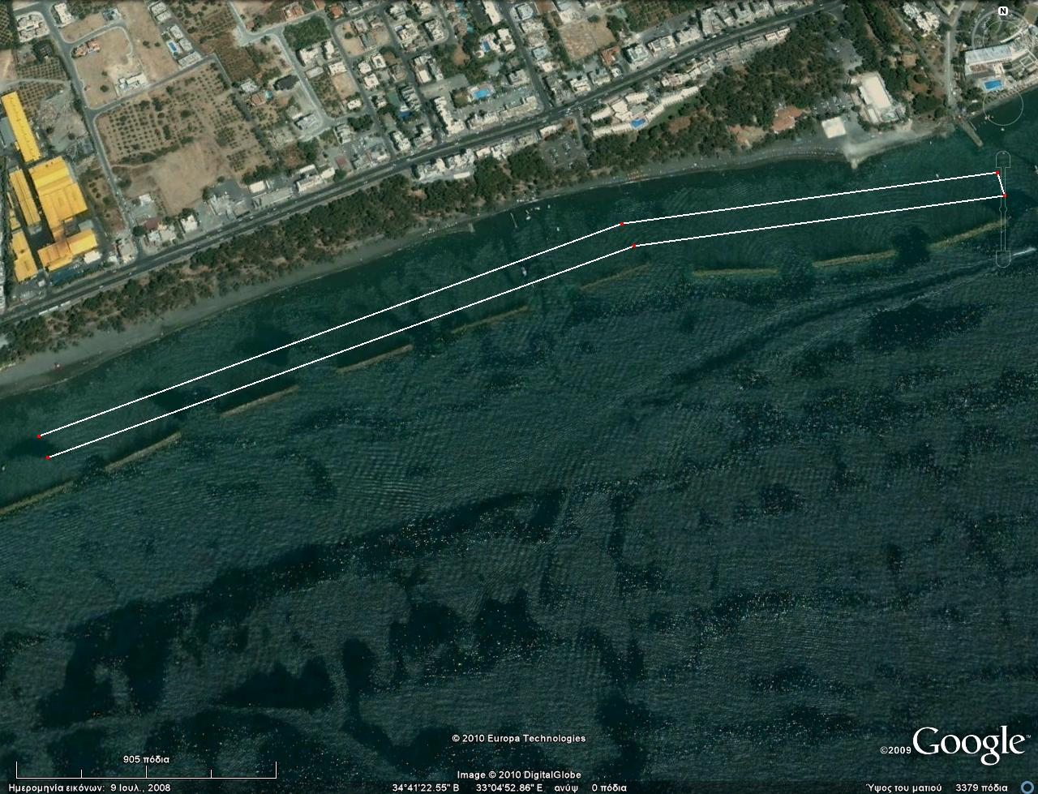
1250m
TURN
CLUB
PARK BEACH HOTEL
HOTHOTEL
START
FINISH / TURN
1000m
1250m
TURN

